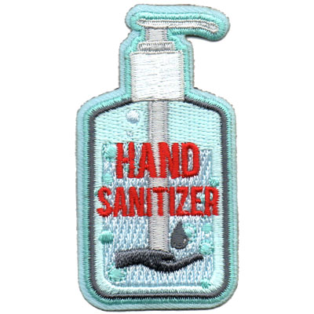
A Scout is Clean Patch

Hi Scouts,

As we are home during these next 2 weeks, it is important for us to help our family keep a clean environment. A Scout is Clean! Washing our hands helps us stop the spread of germs and keep our family healthy. Do these exercises below and earn the “Clean Hands” patch pictured above.

Stay Healthy!
Cubmaster Adam

A. Learn why handwashing is important.

1. Fill a small bowl with water.
2. Add some pepper. The pepper is the germs in our environment.
3. Put a finger in the bowl and take it out.
4. What happened?

__________________________________________________________

__________________________________________________________

5. Now fill a small bowl with soap.
6. Put a different finger in the bowl of soap.
7. Put the soapy finger in the bowl of water and pepper?
8. What happened?

__________________________________________________________

__________________________________________________________

B. Why do we need to wash our hands?

1. Take a look at the pictures below of pieces of bread that have been touched by different hands with various levels of cleanliness. The pieces of bread were put in plastic bags for 1 month.

Bag #1 hands that touched a chromebook
Bag #2 is a control piece of bread. It was untouched.
Bag #3 dirty hands
Bag #4 hands washed by soap and water
Bag #5 hands cleaned by hand sanitizer

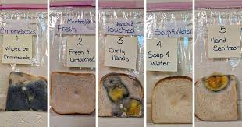

2. What did you learn from this experiment?

_______________________________________________________

_______________________________________________________

C. Importance of washing hands for 30 seconds

1. Look at the photos below of our hands before handwashing. We have lots of germs on our hands. Look at how many germs are left on our hands if we only rinse with water, wash for 6 seconds and don’t use soap, wash for 6 seconds with soap, wash for 15 seconds with soap and wash for 30 seconds with soap.
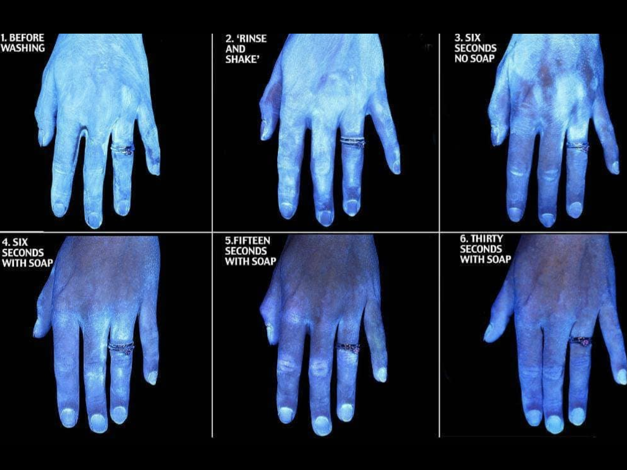

2. What did you learn from this experiment?

_____________________________________________________

______________________________________________________

D. How are you helping your family keep a clean environment at home?

_______________________________________________________

_______________________________________________________

Parent guide: For experiment A, pepper should attract to their finger when they put it in the bowl. When they put a soapy finger in the bowl, the pepper should repel away. For experiment B, there are lots of different conclusions they can gather from the pictures of bread. For experiment C, washing hands for 30 seconds with soap and water should help get rid of the most germs.

